**EXERCISE:**





**Question 1**

**i)**

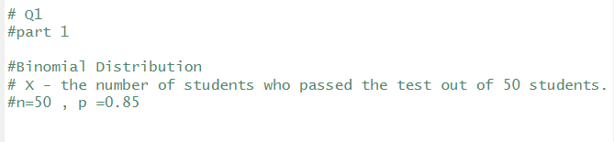

**ii)**

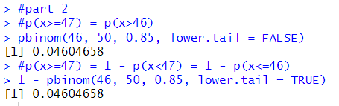

**Question 2**

**i)**

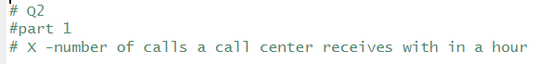

**ii)**



**iii)**

